**Assignment -1**

Python Programming

|  |  |
| --- | --- |
| Assignment Date | 9 September 2022 |
| Student Name | SHINY.R |
| Student Roll Number | 311419205036 |
| Maximum Marks | 2 Marks |

# Basic Python

**Question-1:**  **Split this string:**

s = "Hi there Sam!"

**Solution:**

## print(s.split())

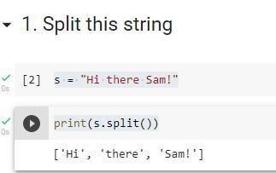

**Question-2:**

**Use .format() to print the following string.**

**Output should be: The diameter of Earth is 12742 kilometers.**

**Solution:**

planet = "Earth" diameter = 12742 print ("the diameter of {} is {} kilometers.".format(planet,diameter))

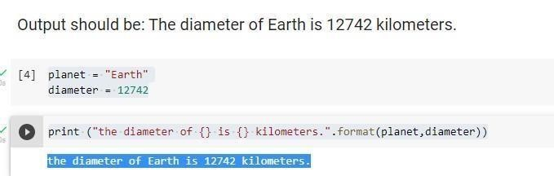

**Question-3:**

**In this nest dictionary grab the word "hello"**

**Solution:**

d = {'k1':[1,2,3,{'tricky':['oh','man','inception',{'target':[1,2,3,'he

llo']}]}]} d['k1'][3]['tricky'][3]['target'][3]

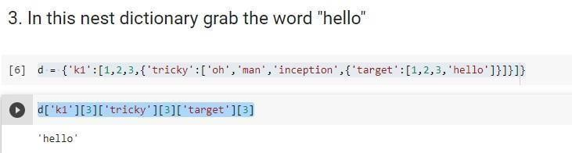

### Numpy

import numpy as np

**Question-4:**

**4.1 Create an array of 10 zeros?**

**Solution:**

array1=np.zeros(10) print(array1)

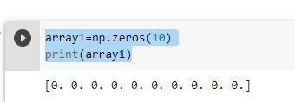

**4.2 Create an array of 10 fives?**

**Solution:**

array2=np.ones(10)*5 print(array2)

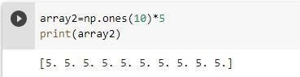

**Question-5:**

**Create an array of all the even integers from 20 to 35**

**Solution:**

array3=np.arange(20,35,2) print(array3)

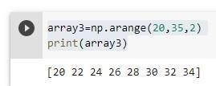

**Question-6:**

**Create a 3x3 matrix with values ranging from 0 to 8**

**Solution:**

matrix=np.arange(0,9).reshape(3,3) print(matrix)

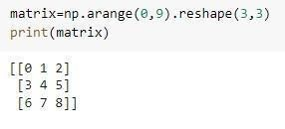

**Question-7:**

**Concatenate a and b** **a = np.array([1, 2, 3]), b = np.array([4, 5, 6])**  **Solution:**

a=np.array([1,2,3]) b=np.array([4,5,6]) c=np.concatenate((a,b)) c d=np.concatenate((a,b),axis=0,out=None) print

(d)

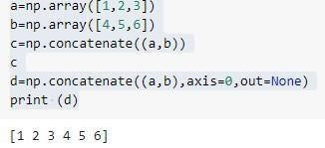

### Pandas

import pandas as pd

**Question-8:**

**Create a dataframe with 3 rows and 2 columns Solution:**

data=[['xxx',1],['yyy',2],['zzz',3]] df= pd.DataFrame(data,columns=['name','number']) df

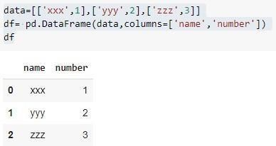

**Question-9:**

**Generate the series of dates from 1st Jan, 2023 to 10th Feb, 2023** **Solution:**

sd=pd.date_range(start='1-1-2023',end='10-02-2023') print (s

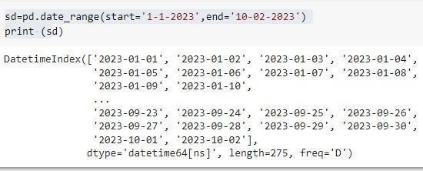

**Question-10:**

**Create 2D list to DataFrame** lists = [[1, 'aaa',

22], [2, 'bbb', 25], [3, 'ccc', 24]] **Solution:**

lists = [[1, 'aaa', 22], [2, 'bbb', 25], [3, 'ccc', 24]]

df=pd.DataFrame(lists,columns=['sno','name','age']) print (df)

